# UNIVERSITY INSTITUTE OF COMPUTING

**PROJECT REPORT**

### Program Name: BCA

Subject Name/Code: Desktop Publishing

**Submitted by: Submitted to:**

**Name: Shubham Prasad Name: Jasleen Kaur**

**UID:** 23BCA10041 Designation – Assistant professor

**Section: BCA –** 2 **“A”**

### Process

#### 1. ****Set Up the Canvas****

* Open Adobe Photoshop and create a new document with a suitable size (e.g., 1080x1920 pixels for a vertical format).
* Choose a high resolution (300 DPI) for better quality.

#### 2. ****Background Layer****

* Use a dark, cloudy, or misty texture as the background layer to create a moody atmosphere. You can either find a cloud texture online or use Photoshop's brushes to paint one.
* Apply a **Gaussian Blur** (Filter > Blur > Gaussian Blur) to make it less distracting and blend well with other elements.

#### 3. ****Adding the Characters****

* Import or paste the images of the main characters. In this example, there's a split image of a character’s face (half human, half skeletal or monster form).
* Use the **Pen Tool** (P) to carefully cut out the character from the original images. Place the face in the top section of your canvas.
* Position the body in the bottom center as the focal point facing the split-face portrait.

#### 4. ****Creating the Split Face Effect****

* Place the two images (human side and monster side) next to each other, aligning them at the center.
* Add a **Layer Mask** to each layer, then use a **Soft Brush** (with black as the foreground color) to blend the edges where the two halves meet, creating a seamless split effect.
* To enhance the split line, you can add a glowing line in the middle:
  + Use the **Brush Tool** with a light blue color to draw a line along the center.
  + Apply a **Outer Glow** effect in the Layer Style to make it emit light.

#### 5. ****Add Background Characters or Silhouettes****

* In this image, there are faint images of other characters in the background, which adds depth.
* Import additional character images and reduce their **Opacity** to 20-30% so they blend into the background.
* Apply a **Gaussian Blur** for added depth.

#### 6. ****Enhancing the Scene with Light and Effects****

* Add a glow or beam effect where the split line is by creating a new layer, drawing a line with a soft, large brush, and then setting the **Blend Mode** to **Overlay** or **Screen**.
* Use **Lens Flare** (Filter > Render > Lens Flare) on a new layer to add light effects around the character to give a dramatic look.

#### 7. ****Adding Shadows and Depth****

* For the main character’s body, add shadows by creating a new layer below the character and using a soft black brush.
* Consider using **Blending Modes** like **Multiply** for shadow layers to make them look more natural.

#### 8. ****Final Adjustments and Color Grading****

* Use **Color Balance** (Image > Adjustments > Color Balance) to add a blue tint to the entire image for a cohesive look.
* Apply **Curves** (Image > Adjustments > Curves) to adjust contrast and make the colors pop.
* Experiment with **Gradient Maps** for color grading. For instance, a gradient from blue to black can give a cold, dramatic tone.
* Adjust the **Saturation** and **Brightness/Contrast** as needed.

#### 9. ****Final Touches****

* Add a vignette effect by creating a new layer, using a large soft brush to paint black around the edges, and reducing the **Opacity**.
* Zoom out and review the overall composition, making sure all elements blend well.

### Key Photoshop Tools and Techniques Used

* **Layer Masks** for blending images.
* **Pen Tool** for precise selection.
* **Layer Styles** for glow and shadow effects.
* **Blending Modes** like Screen and Overlay to add lighting effects.
* **Adjustment Layers** (Curves, Color Balance, Gradient Maps) for color grading.

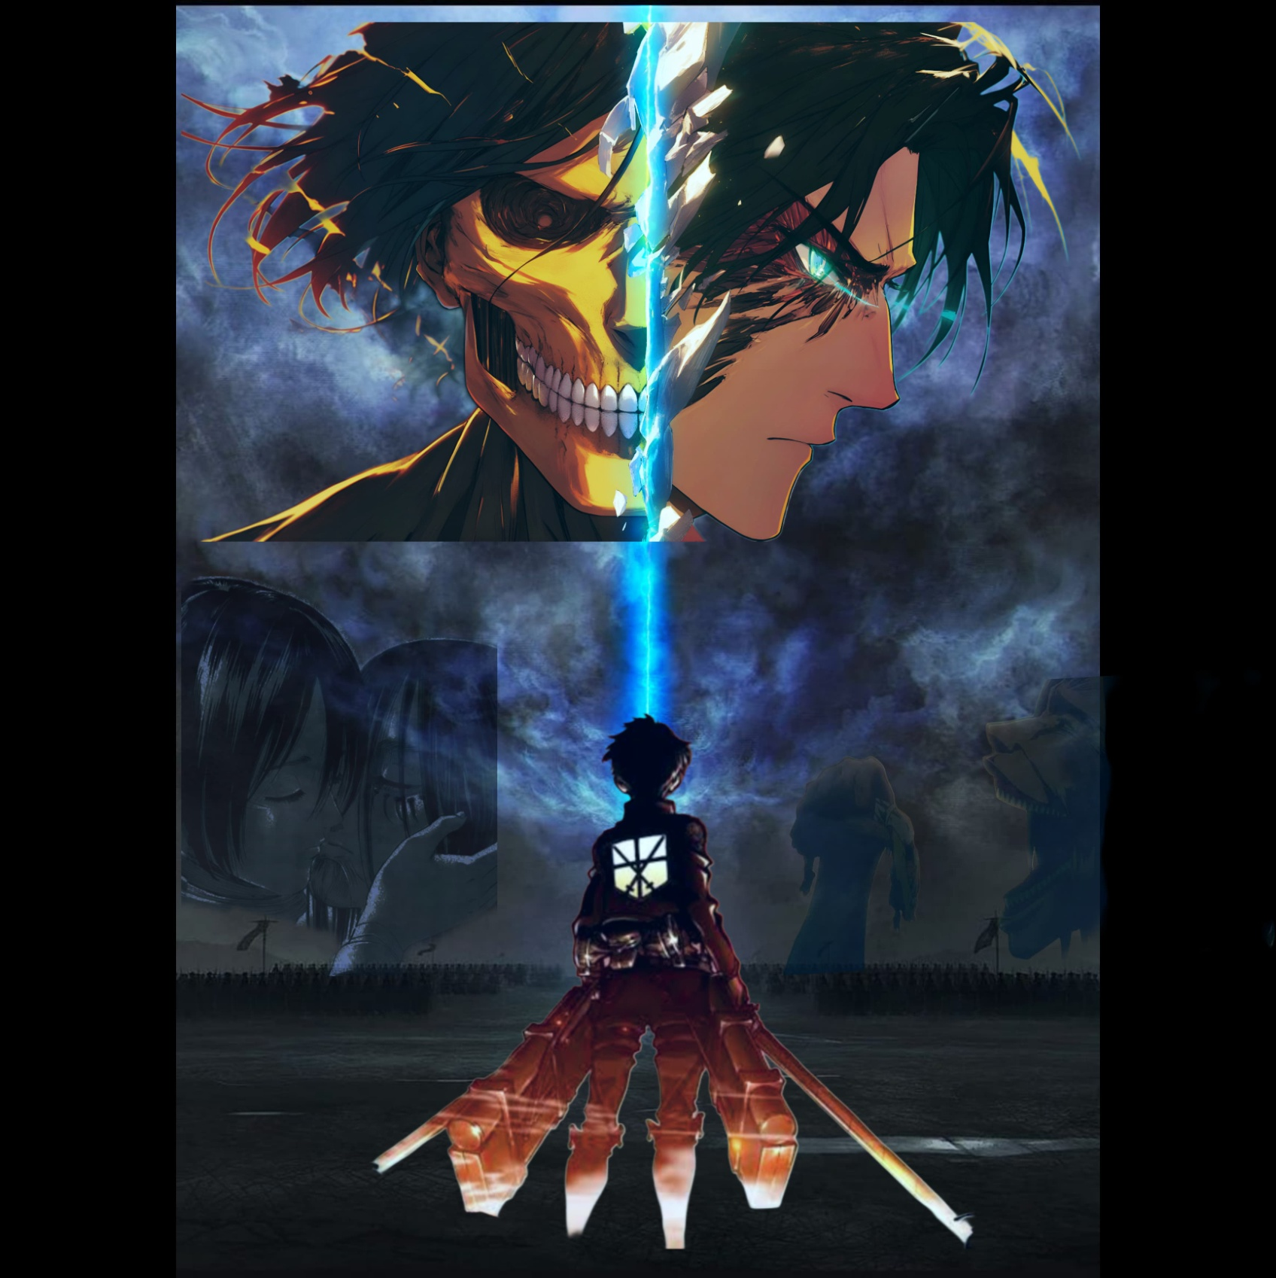

**Story**

In the smoky twilight of a war-torn world, Eren Yeager stood alone, his back facing the legions of titans he once saw as enemies and now commanded like a vengeful god. The battlefield was silent, as if holding its breath in anticipation of what he might do next. Eren’s gaze was set forward, fixed on something far beyond the scorched land and the horizon, but in his mind, memories flickered—glimpses of faces and voices he could never forget.

Above him, an ethereal image split the sky in two. On one side, his face, the boy he had once been: hopeful, angry, and driven by dreams of freedom. On the other side, the face of a monster—a twisted, terrifying mirror image of himself, grinning with the hollow eyes and sharp teeth of his titan form. Between them was a crack of light, the jagged, electric blue line of his choices, his actions, tearing apart who he had been and who he had become.

As he looked up at this ghostly reflection, he could almost hear voices echoing from the past, and for a moment, the battlefield around him faded into memories.

He saw Mikasa, her face close to his, tears streaming down as she tried to reach him. He heard Armin’s desperate cries, urging him to remember who he was, what they had fought for. And he felt the pull of his own heart, torn between the boy who dreamed of freedom and the man willing to sacrifice everything to achieve it.

But that dream of freedom was no longer simple. The cost had twisted and morphed it into something dark and monstrous, a path drenched in blood and suffering. He wanted to be free—not only from the titans or the walls but from the cycle of hatred and revenge that had bound his people for centuries. And yet, standing here, he knew that freedom had a price he was willing to pay, even if it meant becoming a monster in the eyes of the world.

In the distance, he saw the familiar forms of colossal titans, standing in silent obedience, their shadows stretching across the plains like the dark fingers of fate. Each step forward had brought him closer to this moment, and there was no turning back. But as he stared up at the split face above him, he felt the weight of his choices pressing down like an iron shackle, the line between monster and man fraying with each heartbeat.

With a deep breath, Eren reached for his blade. The blade wasn’t just a weapon anymore—it was a symbol, the last fragment of his humanity, a reminder of all he had once been and all he had lost. He lifted it, the metal glinting in the unnatural blue light that slashed across the sky.

“Is this what you wanted, Eren?” he whispered to himself, almost like a prayer or a challenge. "Freedom at any cost?"

The echoes of his past answered in silence, leaving him alone with the weight of his destiny.

He could almost feel the warmth of Mikasa’s hand on his shoulder, the camaraderie he’d shared with Armin, the faith Levi had shown in him despite his doubts. These memories felt like phantoms, slipping through his fingers even as he tried to hold on. But there was no place for them on this path.

With one last look at the divided image of his own face in the sky, he turned his back on it, facing forward. Behind him, the titans awaited his command, silent but powerful, embodying the unstoppable force of his will.

The time had come.

With a single thought, he commanded the titans to move, their colossal feet shaking the earth as they marched forward, a relentless tide of destruction that would sweep away anything in its path. Eren’s heart pounded, not with fear or regret, but with a strange, haunting sense of peace. He had chosen his path, fully accepting the monster he had become.

In his heart, he whispered a farewell to the boy he once was, the one who had dreamed of freedom and hope. And as he walked, his shadow stretched long over the battlefield, leading his army into the unknown, toward a future that only he could see.

